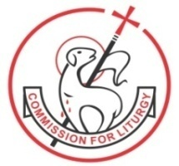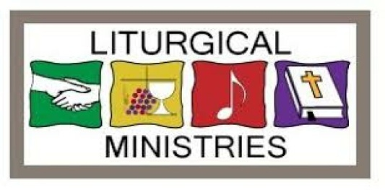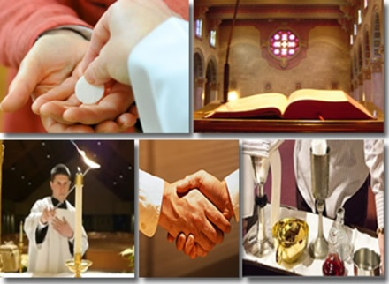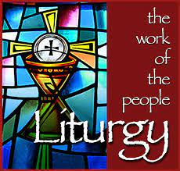

**TOPICS**

**For details & course fees:**

**Email:** [**liturgycentre@gmail.com**](mailto:liturgycentre@gmail.com)

**Website:** [**www.liturgycentrebandra.org**](http://www.liturgycentrebandra.org)

**Phone:** **7710894773**

* **Introduction to Liturgy**
* **Liturgy in the CCC & Sacrosanctum Concilium**
* **Basic Interior Attitudes**
* **Structure of the Mass - Word and Rite**
* **The Paschal Mystery**
* **Celebrating the Lectionary**
* **Celebrating Time: Sunday, the Lord’s Day**
* **The Liturgical Year (Lent & Easter Cycle)**
* **Liturgical Year: The Sanctoral, order of precedence**
* **Liturgy and Popular Devotions**
* **Sacraments and Sacramentals**
* **Liturgy: A celebration in signs and symbols**
* **Liturgical Music**
* **Wedding and Funeral Liturgies**
* **Preparing Liturgies**

**Dies Domini**

**COMMISSION FOR LITURGY, ARCHDIOCESE OF BOMBAY**

**BASIC LITURGY MINISTRY COURSE 2024 - 25**

**(One Sunday Every Month)**