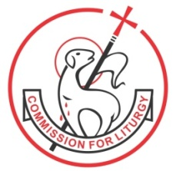

Basic Liturgical Ministry Course 2023–2024

Inauguration date: 9th July 2023 at 9.30 am (followed by class)

Venue: Bosco Hall, St Andrew’s Church, 115 Bandra (W) Mumbai.
(Sessions will be conducted with physical presence)
(Google Meet facility available ONLY for those outside Mumbai)

All other Sundays: 10.00 am – 4.00 pm
(7 Sundays, 2 sessions every Sunday)

1. Sunday 9th July
2. Sunday 13th August
3. Sunday 10th September
4. Sunday 8th October
5. Sunday 12th November
6. Sunday 10th December
7. Sunday 14th January

Graduation Day:
Sunday 10th March 2024 from 5.00 pm - 8.00 pm

Course Requirements:
Commitment to serve at the Parish level
Recommendation letter from the Parish Priest / Superior
Active participation in all sessions
Regular attendance, MCQ examination and submission of all assignments

Interviews: Tuesday, Thursday and Friday, 10.00 am - 4.00 pm, by appointment
Course Fee: Rs. 7,000/- (Not inclusive of food)

Cheque to be drawn in favour of Diocesan Liturgy Centre
NEFT Details: Account No: 2090052000019426. IFSC CODE: CCBL0209005
Contact: Diocesan Liturgy Centre, opp. Mount Mary Basilica, 4 Kane Road, Bandra (West).
Timing: 10.00 am – 4.00 pm

Tel: +91 7710894773
Email: liturgycentre@gmail.com
Website: www.liturgycentrebandra.org

